Lab – Configuring a Wireless Router and Client

1. Topology

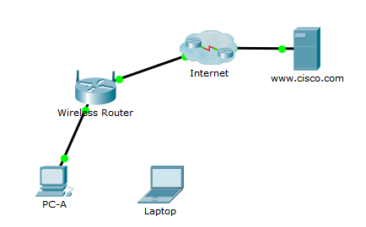

1. Objectives

* Configure Basic Settings on a Wireless Router
* Connect a Wireless Client

1. Background / Scenario

In this activity, you will configure a wireless router, which includes applying WPA2 security settings and activating DHCP services. You will also configure a wireless PC client.

**Note:** This activity will start with some assessment items already scored as correct. This will ensure that your configurations do not change these initial settings.

* + 1. Configure the Wireless Settings for the Wireless Router.
       1. Click **Fast Forward Time** to speed up network convergence.
       2. Click **PC-A > Desktop > Web Browser** and enter the IP address 192.168.0.1 to connect to the wireless router.
       3. Enter **admin** as the default username and password.
       4. For the **Internet Setup**, leave the default setting as **Automatic Configuration - DHCP**.
       5. For the local **Network Setup**, enable the DHCP server with the following settings
          1. Set the router’s **IP Address** to 192.168.100.1 and the **Subnet Mask** is 255.255.255.0.
          2. Set the **Maximum number of Users** to 150.
          3. Set the **Static DNS 1** address to 209.165.200.10.
       6. Scroll to the bottom and click **Save Settings**. **PC-A** will be disconnected from the **Wireless Router**.
       7. On **PC-A**, close the **Web Browser** window. Then click **Command Prompt** and enter the command **ipconfig /renew**.
       8. Close the **Command Prompt** window. Then click **Web Browser** and enter **192.168.100.1** to re-access the **Wireless Router** web interface.
       9. Click the **Wireless** tab and configure the **SSID** as **Home-Net**. Scroll to the bottom and click **Save Settings**.
       10. Click Continue and scroll back to the top. Click the **Wireless Security** sub-tab. Set the **Security Mode** to **WPA2 Personal** and set the Passphrase to **cisco123**. Scroll to the bottom and click **Save Settings**.
       11. Click Continue and scroll back to the top. Click the **Administration** tab and change the **Router Password** to **cisco12345**. Scroll to the bottom and click **Save Settings**. You will be asked to enter the new password. The User Name is still **admin**.
    2. Connect a Wireless Client.
       1. Click **Laptop > Config > Wireless0**. Set the **Port Status** to **On**.
       2. Set the **SSID** and **WPA2-PSK** passphrase to match your configuration in Step 1.
       3. Click **Desktop > Web Browser** and enter **www.cisco.com** to test the Laptop’s connectivity to the Internet.

**Note**: The web page may take a several seconds to appear. To speed up the process, you can click **Fast Forward Time** in the main Packet Tracer window.

* + - 1. The web page should appear. If not, verify all the settings in Step 1 and Step 2.
      2. **Challenge**: Add a wireless tablet and smartphone to the network. Configure the wireless settings and verify connectivity to **www.cisco.com**.